**Movie-Suggestion-Website**

Movie suggestion website gives us movies based on our genre picked. I had done the project-based on HTML, CSS and JavaScript. And I choose TMDB (The Movie Database) website for the movies data. The Movie Database (TMDB) is a popular, user editable database for movies and TV shows.

**Features**

**Genre:**

With this feature I can pick movies based on selected genre, I can select one or multiple genres at a time.

And if there are no movies on selected genre it shows no results found

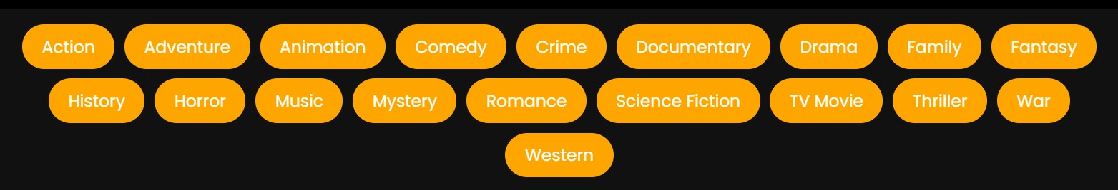

These are the genres I included in the website

**Search:**

I can search any movie or tv show by name on search feature, so I can get the overview of the movie and also the IMDB rating of the movie.



**Overview and IMDB rating:**

I can see overview and IMDB rating of any movie on moving cursor to the particular movie.



**Technology Used:**

The data I used on this website are most popular movies so the website will be updated based on rating and popularity. So, basically the movies are sorted based on popularity.

So, for the data I used for the website requires API key

**GITHUB Link:**

<https://github.com/srujan-27/Movie-Sugesstion-Website.git>